Adetayo Adekunle
5.1 Glossary Creation:
Used the answer key that your provided the class for questions 5.1 and 5.2
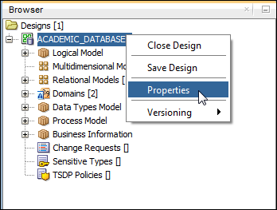
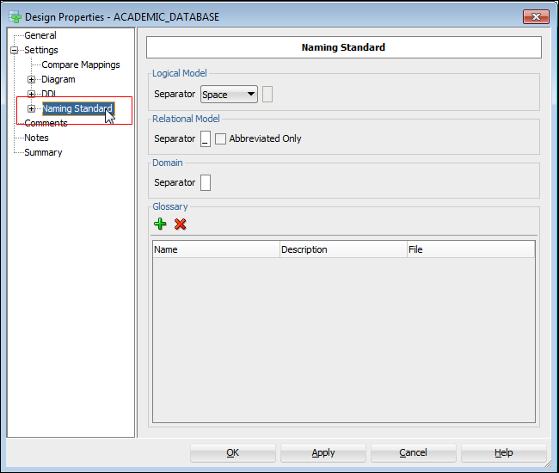

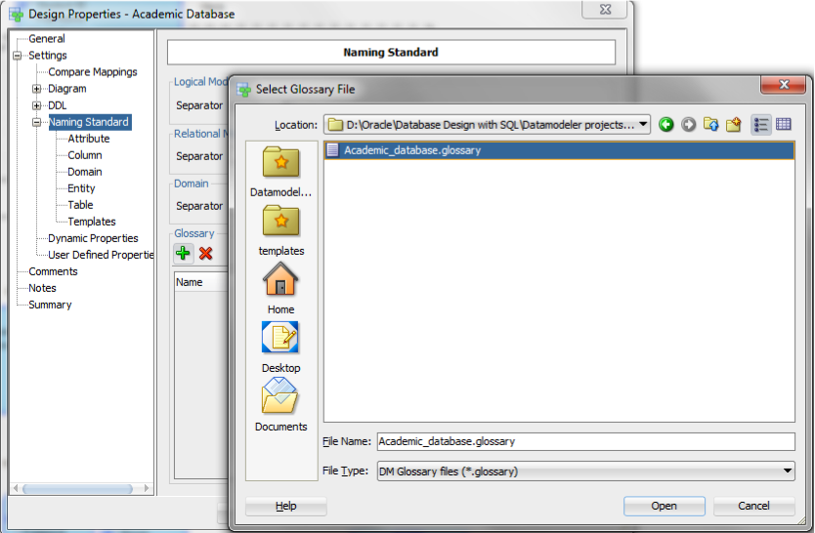

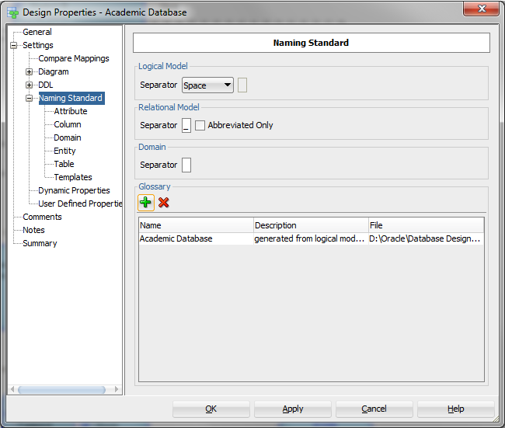

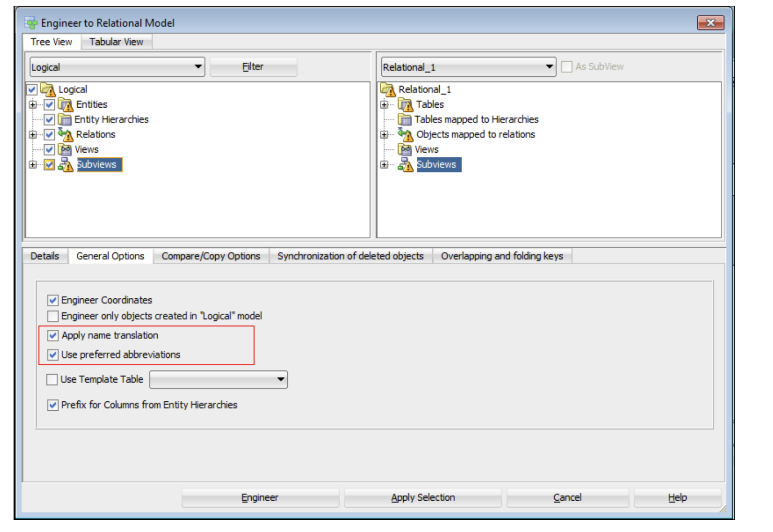

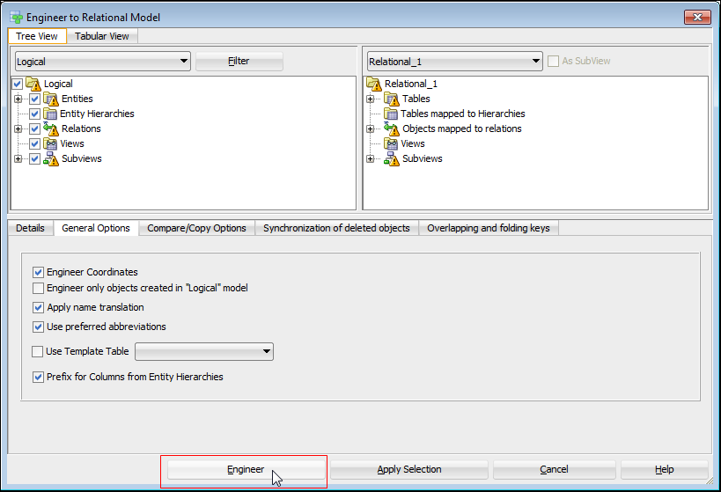

5-2: Exercise 1:
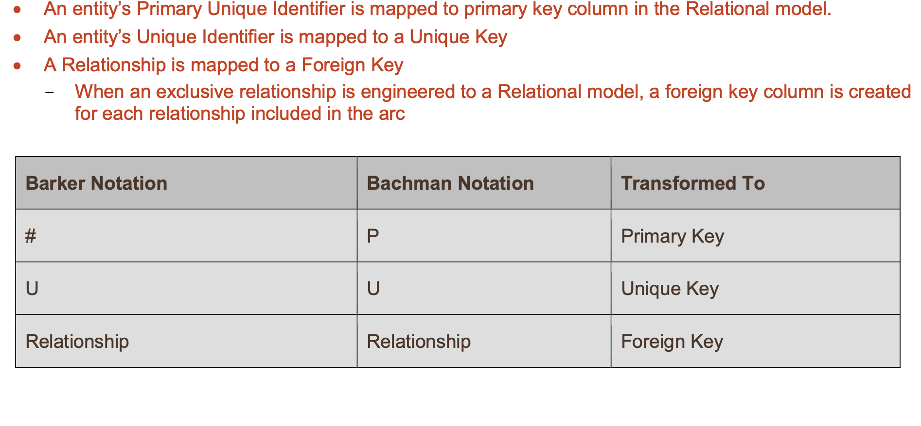

Mapping Logical model and Relational Model:
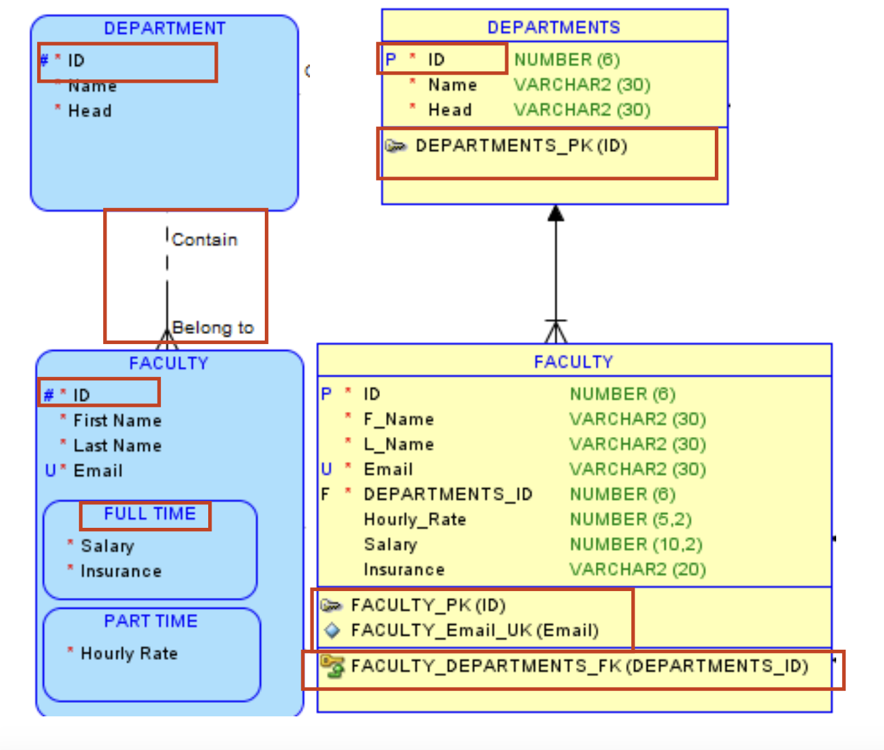
Exercise 2:
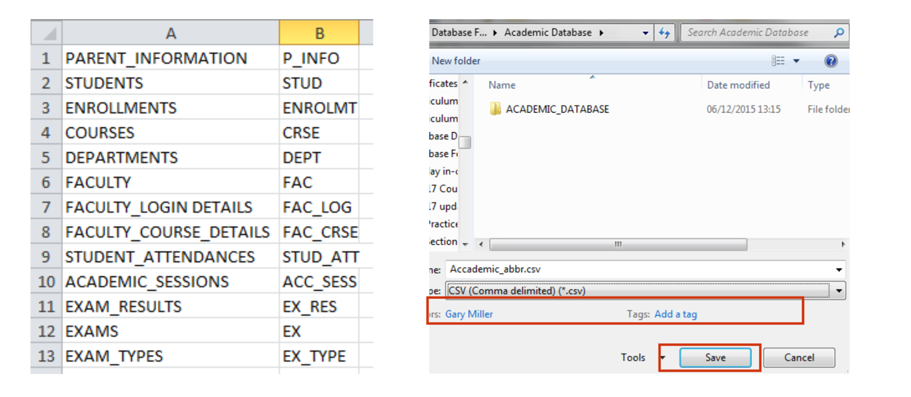
Exercise 3:
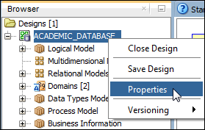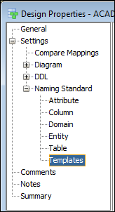

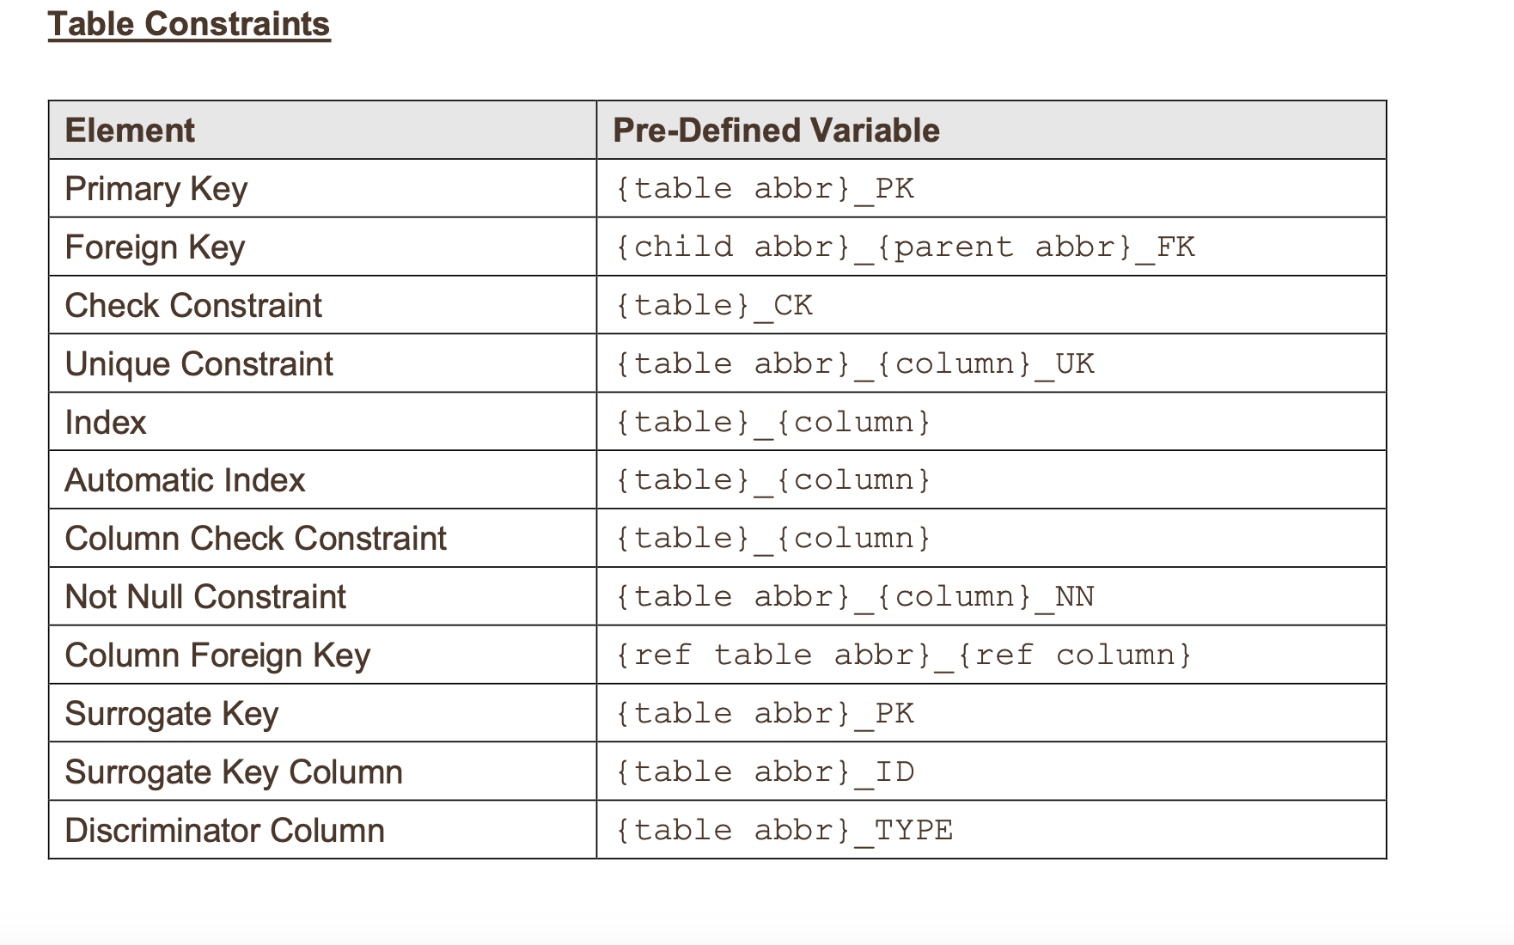
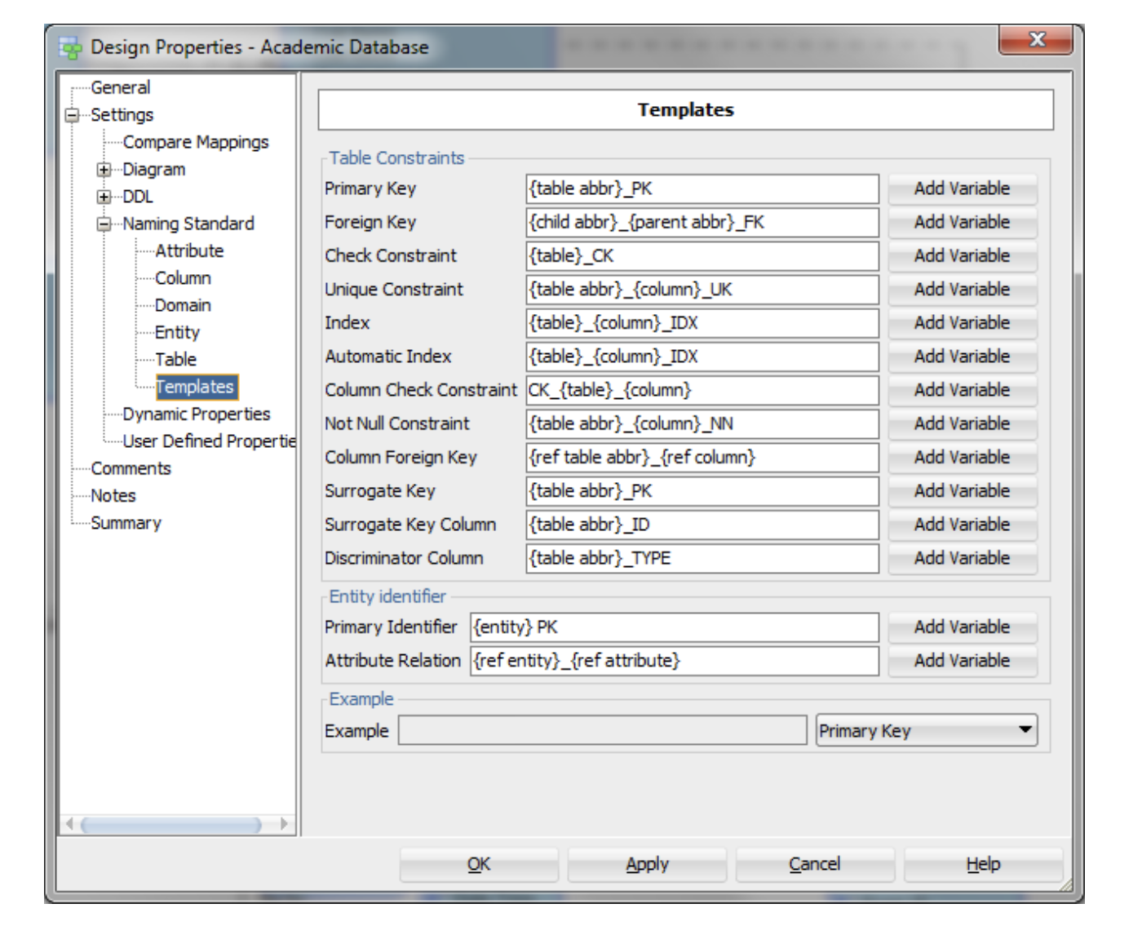

Exercise 4:

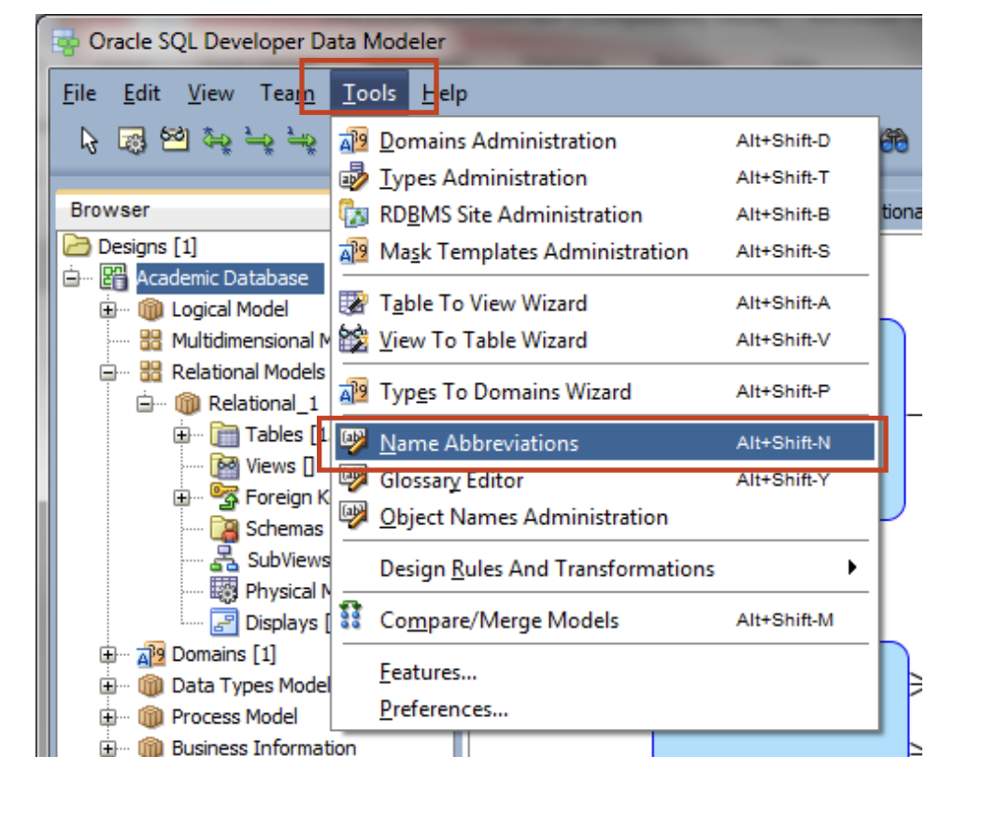
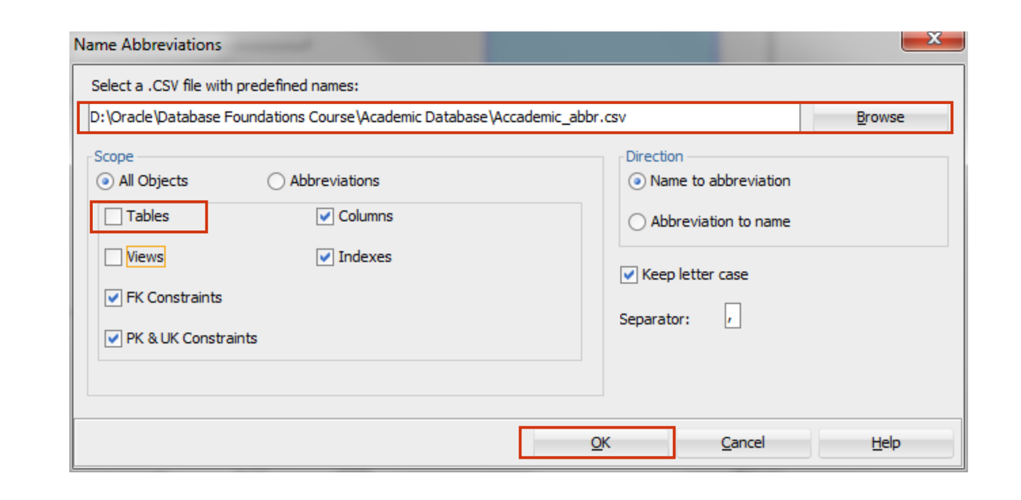
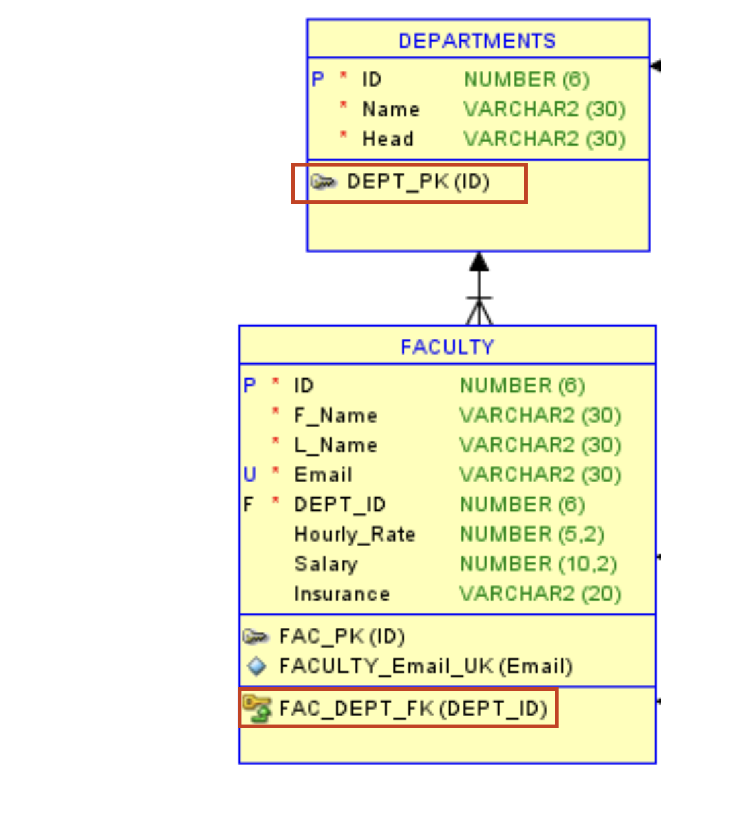
Exercise 5:
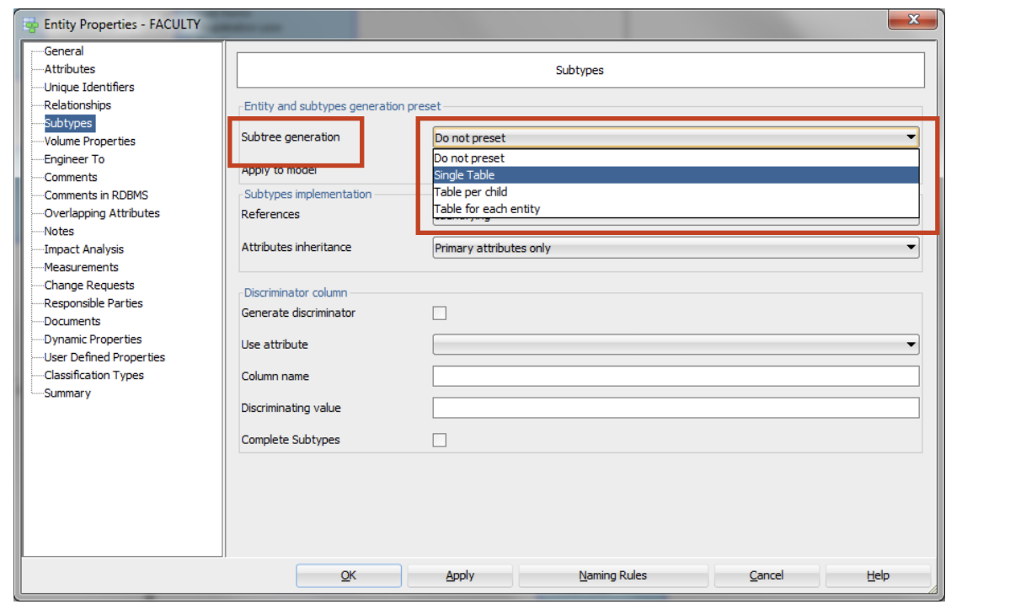

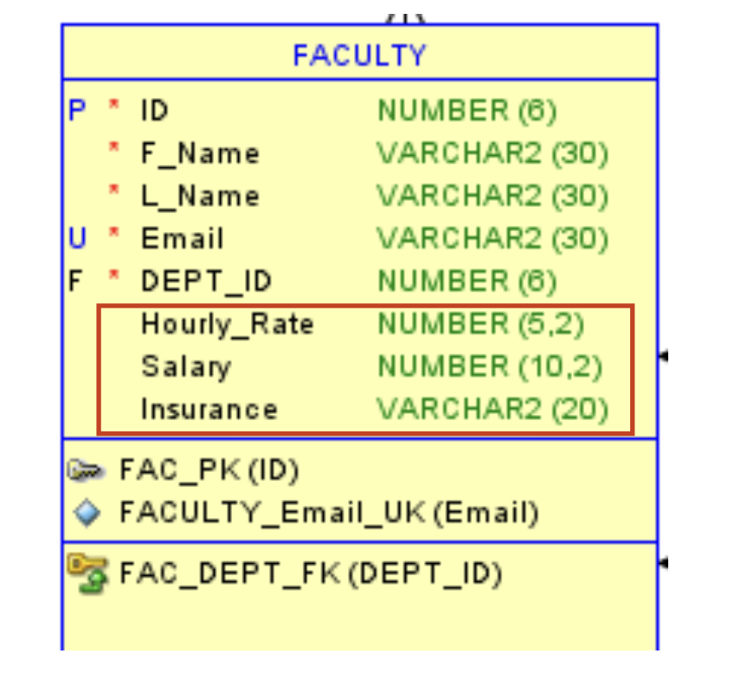
6.3 Exercise 1:
Course Name:
CREATE TABLE AD_COURSES (
course_id NUMBER PRIMARY KEY, course_name VARCHAR2(100) NOT NULL, department_id NUMBER NOT NULL
);
Department Name:
CREATE TABLE AD_DEPARTMENTS ( department_id NUMBER PRIMARY KEY, department_name VARCHAR2(100) NOT NULL
);

Student Email:
CREATE TABLE AD_STUDENTS (
student_id NUMBER PRIMARY KEY,
student_name VARCHAR2(100) NOT NULL, student_email VARCHAR2(100) UNIQUE NOT NULL
);
Faculty Email:
CREATE TABLE AD_FACULTY (
faculty_id NUMBER PRIMARY KEY,
faculty_name VARCHAR2(100) NOT NULL, faculty_email VARCHAR2(100) UNIQUE NOT NULL
);
Session Name:
CREATE TABLE AD_ACADEMIC_SESSIONS (
session_id NUMBER PRIMARY KEY,
session_name VARCHAR2(100) UNIQUE NOT NULL, start_date DATE NOT NULL,
end_date DATE NOT NULL );
Altering The Tables:
ALTER TABLE AD_COURSES
ADD CONSTRAINT fk_department FOREIGN KEY (department_id) REFERENCES AD_DEPARTMENTS (department_id);
ALTER TABLE AD_STUDENTS
ADD CONSTRAINT pk_student PRIMARY KEY (student_id);
ALTER TABLE AD_FACULTY
ADD CONSTRAINT pk_faculty PRIMARY KEY (faculty_id);
Exercise 2:
ALTER TABLE AD_FACULTY_LOGIN_DETAILS MODIFY (LOGIN_DATE_TIME DEFAULT SYSDATE);
ALTER TABLE AD_PARENT_INFORMATION SET READ ONLY;

Exercise 3:
CREATE TABLE DEPT (
dept_id NUMBER(8),
dept_name VARCHAR2(30), loc_id NUMBER(4),
PRIMARY KEY (dept_id, loc_id)
);
CREATE TABLE SUPPLIERS (
sup_id NUMBER(15),
sup_name VARCHAR2(30), contact_name NUMBER(4), PRIMARY KEY (sup_id, sup_name)
);
CREATE TABLE PRODUCTS (
product_id NUMBER(10) PRIMARY KEY,
sup_id NUMBER(15) NOT NULL,
sup_name VARCHAR2(30) NOT NULL,
FOREIGN KEY (sup_id, sup_name) REFERENCES SUPPLIERS (sup_id,
sup_name) );
CREATE TABLE DEPT_SAMPLE ( dept_id NUMBER(8), dept_name VARCHAR2(30), loc_id NUMBER(4),
UNIQUE (dept_id, dept_name)
);
6.4:
Exercise 1:
INSERT INTO AD_ACADEMIC_SESSIONS (ID, NAME) VALUES (100, 'SPRING SESSION'),
(200, 'FALL SESSION'),
(300, 'SUMMER SESSION');
INSERT INTO AD_DEPARTMENTS (ID, NAME, HEAD) VALUES (10, 'ACCOUNTING', 'MARK SMITH'),
(20, 'BIOLOGY', 'DAVE GOLD'),
(30, 'COMPUTER SCIENCE', 'LINDA BROWN'), (40, 'LITERATURE', 'ANITA TAYLOR');
ALTER TABLE AD_PARENT_INFORMATION READ WRITE;
INSERT INTO AD_PARENT_INFORMATION (ID, PARENT1_FN, PARENT1_LN, PARENT2_FN, PARENT2_LN)
VALUES (600, 'NEIL', 'SMITH', 'DORIS', 'SMITH'),
(610, 'WILLIAM', 'BEN', 'NITA', 'BEN'), (620, 'SEAN', 'TAYLOR', 'RHEA', 'TAYLOR'), (630, 'DAVE', 'CARMEN', 'CATHY', 'CARMEN'), (640, 'JOHN', 'AUDRY', 'JANE', 'AUDRY');
INSERT INTO AD_STUDENTS (ID, FIRST_NAME, LAST_NAME, REG_YEAR, EMAIL, PARENT_ID)
VALUES (720, 'JACK', 'SMITH', '01-Jan-2012', 'JSMITH@SCHOOL.EDU', 600),
(730, 'NOAH', 'AUDRY', '01-Jan-2012', 'NAUDRY@SCHOOL.EDU', 640),
(740, 'RHONDA', 'TAYLOR', '01-Sep-2012', 'RTAYLOR@SCHOOL.EDU', 620),
(750, 'ROBERT', 'BEN', '01-Mar-2012', 'RBEN@SCHOOL.EDU', 610), (760, 'JEANNE', 'BEN', '01-Mar-2012', 'JBEN@SCHOOL.EDU', 610), (770, 'MILLS', 'CARMEN', '01-Apr-2013', 'MCARMEN@SCHOOL.EDU',
630);
INSERT INTO AD_COURSES (ID, NAME, SESSION_ID, DEPT_ID, BUILDING, ROOM, DATE_TIME)
VALUES (195, 'CELL BIOLOGY', 200, 20, 'BUILDING D', 401, 'MWF 9-10'),
(190, 'PRINCIPLES OF ACCOUNTING', 100, 10, 'BUILDING A', 101, 'MWF 12-1'),
(191, 'INTRODUCTION TO BUSINESS LAW', 100, 10, 'BUILDING B', 201, 'THUR 2-4'),
(192, 'COST ACCOUNTING', 100, 10, 'BUILDING C', 301, 'TUES 5-7'),
(193, 'STRATEGIC TAX PLANNING FOR BUSINESS', 100, 10, 'TAX123', NULL, NULL, NULL),
(194, 'GENERAL BIOLOGY', 200, 20, 'BIO123', NULL, NULL, NULL);
INSERT INTO AD_FACULTY (ID, FIRST_NAME, LAST_NAME, EMAIL, SALARY, INSURANCE, HOURLY_RATE, DEPT_ID)
VALUES (800, 'JILL', 'MILLER', 'JMILL@SCHOOL.EDU', 10000, 'HEALTH', NULL, 20),
(810, 'JAMES', 'BORG', 'JBORG@SCHOOL.EDU', 30000, 'HEALTH,DENTAL', NULL, 10),
(820, 'LYNN', 'BROWN', 'LBROWN@SCHOOL.EDU', NULL, NULL, 50, 30),
(830, 'ARTHUR', 'SMITH', 'ASMITH@SCHOOL.EDU', NULL, NULL, 40, 10),
(840, 'SALLY', 'JONES', 'SJONES@SCHOOL.EDU', 50000, 'HEALTH,DENTAL,VISION', NULL, 40);
Exercise 2:
ALTER TABLE AD_FACULTY_LOGIN_DETAILS ADD (DETAILS VARCHAR2(50));
UPDATE AD_FACULTY_LOGIN_DETAILS
SET DETAILS = 'First Login'
WHERE FACULTY_ID = 800 AND LOGIN_DATE_TIME = TO_TIMESTAMP('01-JUN-17 05.10.39 PM', 'DD-MON-RR HH.MI.SS PM');
UPDATE AD_FACULTY_LOGIN_DETAILS
SET DETAILS = 'Second Login'
WHERE FACULTY_ID = 800 AND LOGIN_DATE_TIME = TO_TIMESTAMP('01-JUN-17 05.13.15 PM', 'DD-MON-RR HH.MI.SS PM');
6.5:
Exercise 1:
Yes, the email will remain because ALTER TABLE is a DDL operation, and DDL changes are committed in Oracle.
Exercise 2:
- The records would stay the same.
- The changes I would see with the transactions is that Student_id = 1 would be reinstated and then it would update to the First_Name equaling Johnny.
6.6:
Exercise 1:

SELECT * FROM AD_FACULTY;
SELECT * FROM AD_COURSES;
SELECT * FROM AD_DEPARTMENTS; SELECT * FROM AD_ACADEMIC_SESSIONS;

SELECT STUDENT_ID, COURSE_ID, EXAM_ID, EXAM_GRADE
FROM AD_EXAM_RESULTS;
- .
SELECT STUDENT_ID, SESSION_ID, NUM_WORK_DAYS, NUM_DAYS_OFF,
EXAM_ELIGIBILITY
FROM AD_STUDENT_ATTENDANCE
WHERE EXAM_ELIGIBILITY = 'Y';
- .
SELECT FACULTY_ID, LOGIN_DATE_TIME FROM
AD_FACULTY_LOGIN_DETAILS;

SELECT NAME AS DEPARTMENT_NAME, HEAD AS DEPARTMENT_HEAD FROM AD_DEPARTMENTS;

720: FIRST NAME IS JACK
SELECT STUDENT_ID | | ' : FIRST NAME IS ' | | FIRST_NAME AS STUDENT_INFO FROM AD_STUDENTS;
7. SELECT DISTINCT EXAM_TYPE FROM AD_EXAMS;
6.7:
Exercise 1:

SELECT *
FROM AD_COURSES
WHERE SESSION_ID = 100;

SELECT *
FROM AD_EXAM_RESULTS WHERE EXAM_GRADE > 95;

SELECT *
FROM AD_EXAM_RESULTS
WHERE EXAM_GRADE BETWEEN 65 AND 70;

SELECT *
FROM AD_STUDENTS
WHERE STUDENT_REG_YEAR > TO_DATE ('01-Jun-2012', 'DD-MON-YYYY');

SELECT *
FROM AD_COURSES
WHERE DEPT_ID IN (10, 30);

SELECT *
FROM AD_STUDENTS
WHERE FIRST_NAME LIKE 'J%' ;

SELECT *
FROM AD_STUDENT_COURSE_DETAILS
WHERE COURSE_ID IN (190, 193);

SELECT *
FROM AD_COURSES
WHERE DEPT_ID = 30 AND SESSION_ID = 200;
- SELECT *
FROM AD_COURSES
WHERE SESSION_ID NOT IN (200, 300);

SELECT *
FROM AD_COURSES
WHERE DEPT_ID = 20;
6.8
Exercise 1:
1. (a).
SELECT *
FROM AD_STUDENTS
ORDER BY STUDENT_REG_YEAR ASC;
(b).
SELECT *
FROM AD_EXAM_RESULTS
ORDER BY STUDENT_ID ASC, COURSE_ID ASC;
(c).
SELECT *
FROM AD_STUDENT_ATTENDANCE ORDER BY STUDENT_ID ASC;
(d).
SELECT *
FROM AD_DEPARTMENTS
ORDER BY DEPT_ID ASC;
2.
SELECT STUDENT_ID, SESSION_ID,
(NUM_DAYS_OFF / NUM_WORK_DAYS) * 100 AS PERCENT_DAYS_OFF
FROM AD_STUDENT_ATTENDANCE ORDER BY PERCENT_DAYS_OFF DESC;
3.
SELECT STUDENT_ID, COURSE_ID, EXAM_GRADE FROM AD_EXAM_RESULTS
ORDER BY EXAM_GRADE DESC FETCH FIRST 5 ROWS ONLY;
4.
SELECT *
FROM AD_PARENT_INFORMATION ORDER BY ID ASC;
6-9 :
Exercise 1:

SELECT C.ID AS COURSE_ID, C.NAME AS COURSE_NAME, D.NAME AS DEPARTMENT_NAME
FROM AD_COURSES C
JOIN AD_DEPARTMENTS D ON C.DEPT_ID = D.ID;

SELECT *
FROM AD_COURSES
WHERE SESSION_ID = 200;
- SELECT C.ID AS COURSE_ID, C.NAME AS COURSE_NAME, D.NAME AS DEPARTMENT_NAME, S.STUDENT_ID, S.GRADE
FROM AD_COURSES C
JOIN AD_DEPARTMENTS D ON C.DEPT_ID = D.ID
JOIN AD_STUDENT_COURSE_DETAILS S ON C.ID = S.COURSE_ID;
- SELECT C.ID AS COURSE_ID, C.NAME AS COURSE_NAME, D.NAME AS DEPARTMENT_NAME, S.STUDENT_ID, S.GRADE
FROM AD_COURSES C
JOIN AD_DEPARTMENTS D ON C.DEPT_ID = D.ID
JOIN AD_STUDENT_COURSE_DETAILS S ON C.ID = S.COURSE_ID WHERE C.DEPT_ID = 20;
- SELECT R.STUDENT_ID, R.COURSE_ID, R.EXAM_GRADE
FROM AD_EXAM_RESULTS R
JOIN AD_COURSES C ON R.COURSE_ID = C.ID WHERE C.ID BETWEEN 190 AND 192;
- SELECT R.STUDENT_ID, R.COURSE_ID, R.EXAM_GRADE, C.NAME AS COURSE_NAME
FROM AD_EXAM_RESULTS R
LEFT JOIN AD_COURSES C ON R.COURSE_ID = C.ID;
- The output will include all row combinations from the AD_EXAMS and AD_EXAM_TYPES tables.

